Memorial Benches
For Traditional & Natural Burial Ground

A memorial bench can be placed in the cemetery in commemoration of a Coleford parish resident.
Memorial benches are available through a lease agreement.
There are three types of benches are available: simple recycled, armed recycled or wooden.
Recycled benches can be leased in colours green, brown or rainbow (please see below image).

It is not permitted to place any other bench in the traditional Cemetery, Garden of Remembrance or the Natural Burial Ground (NBG). Benches can only be placed in locations specified by Coleford Town Council.

Coleford Town Council will supply, install and maintain the bench.

An application must be fully completed, and monies paid in full prior to the bench being purchased and installed. The Council reserves the right to refuse any application without detailed explanation.

A brass plaque can be placed on the memorial bench. The wording of the plaque must be agreed by Coleford Town Council.

After the lease period of 10 years has expired, an extension of lease can be obtained through the Town Council.

Coleford Town Council reserves the right to move or remove any bench if they feel necessary, without detailed explanation.

Price List

Simple bench - Recycled 10 years
Bench cost £ 975.00
Plaque £ 100.00

Armed bench - Recycled
Bench cost £ 1100.00
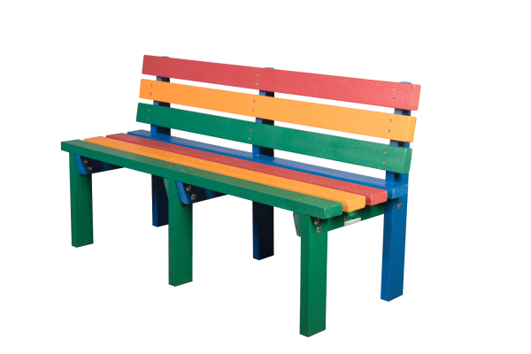
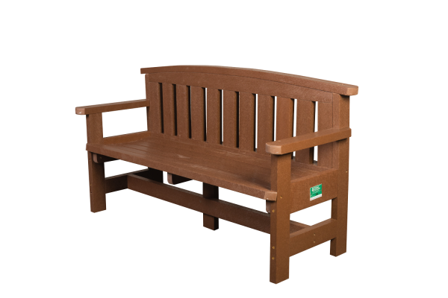
Plaque £ 100.00

Wooden benc
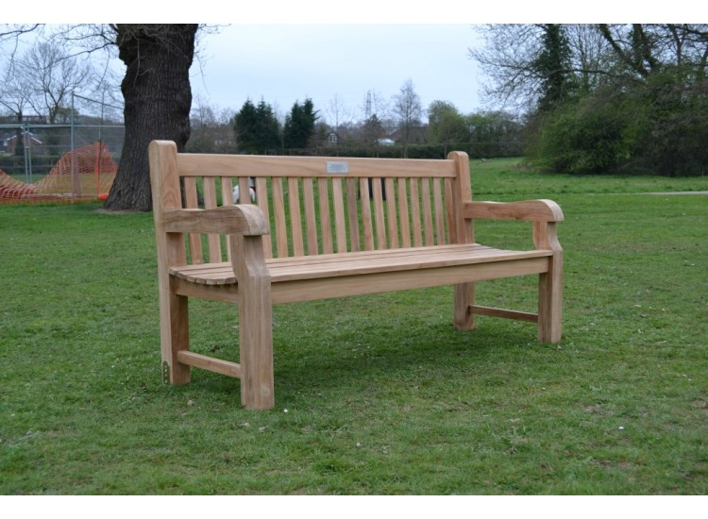
Bench cost £ 2000.00
Plaque £ 100.00

Application Form

Contact Details

Name:
…………………………………………………………………………………………………………………

Address:
………………………………………………………………………………………………………………………………………………………………………………………………………………………………………………………………………………………………………………………………………………………

Phone number: ………………………………………….Email:……………………………………………

Type of Bench

Simple Recycled Armed Recycled Wooden
£975.00 £1100.00 £2000.00

Colour

Brown Green Rainbow

Bench Position ………………………………………………………………………………………….
(to be agreed by CTC)

Brass Plaque Yes No
£100.00

Wording for the plaque
…………………………………………………………………………………………………………………
……………………………………………………………………………………………………………………………………………………………………………………………………………………………………………………………………………………………………………………………………………………….
…………………………………………………………………………………………………………………

For Office use

Date Application Received:……………………………………………………………………………….

Date of Monies Received / Invoice No…………………………………………………………………..

Arrangements……………………………………………………………………………………………….

Date of Purchase:…………………………… Date of Installation:……………………………………..

Date of Lease Expiry:……………………………………………………………………………………….

